**Group 27**

**IS 436 Section 02**

**Structured Systems Analysis and Design**

**Deliverable 3 - Redo**

**11/09/2017**

Bryan Baek

Brendan Bessel

Kalabe Mulugeta

Josiah Tillett

Xinbo Yang

**Table of Contents**

1. Table of Contents…………………………………………...………….………………….1
2. Context Level…………..…………………….………….……….….…………………….2
3. Level 0…………….…....…………………………………………………….…..……….3
4. Simple Text Definition…………….……………………………………………………....4
5. Syntax Checks……………………………………………………………………………..6

VI. Updated Use Cases…………….…………………………………………………………..7

**Context Level**

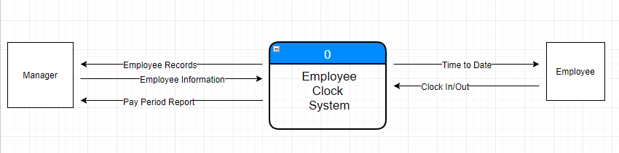

**Level 0 Diagram**

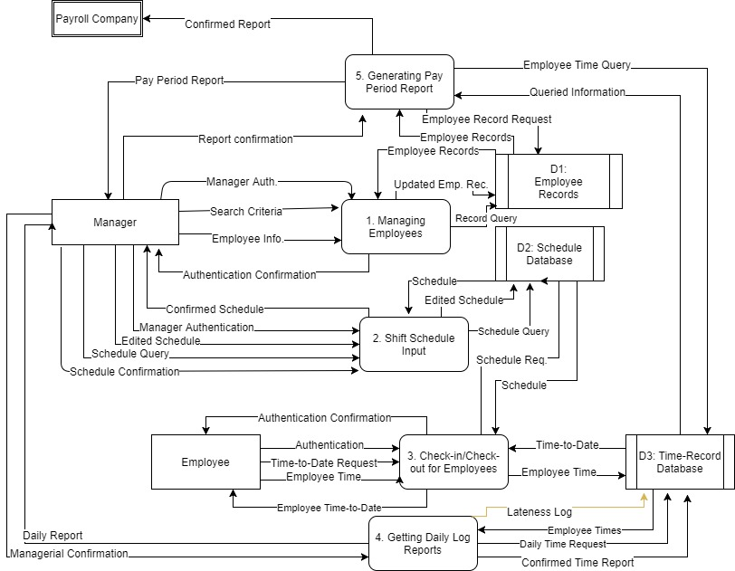

**Simple Text Definition**

**Entity**

* Employee - A person who checks in for a scheduled shift or checks out at the end of their shift
* Manager - A person who oversees the system and be able to manage the employees or edit the schedules.
* Payroll Company - The company that receives pay period report from the system

**Process**

* Managing Employees - describes how managers can alter employee records drawn from the employee database when employee records need to be updated
* Shift Schedule Input - describes how the manager will input the upcoming schedule into the timekeeping system when manager needs to create or change schedule
* Check-in/Check-out for Employees - describes when the employee checks in or checks out, the system will request the time to date from the database and records the employee time to database
* Getting Daily Log Reports - Describes the process where system provides daily log to the manger with managerial confirmation and employee times from time database.
* Generating Pay Period Report - Describe the process of creating a bi-weekly report that shows how many and what type of hours employees have worked during the pay period, as well as their gross pay for the period when the pay period comes to an end.

**Datestore**

* Employee Records - Stores any updates to employee records like their name, address, position, and etc, and provide employee records upon request.
* Schedule Database - Stores information about employee shift edited from managers and provides employee’s schedules upon request
* Time-Record Database - Stores time of check in and out of employees and provides time and dates of each employees upon request

**Data flow**

* Manager Authentication - Managerial information such as manager’s ID and password for managerial access from the manager
* Authentication Confirmation - Confirmation indicated by the system that the user has the access
* Search Criteria - criteria of employee(s) given by manager to the system to look up on database (includes any combinations of employee name, gender, and employee ID)
* Employee Records/Employee Information - Information about Employee like employee name, employee ID, and social security
* Updated Employee Record - New updated record of employee (includes employee name, employee ID, or social security)
* Schedule Query - Request of employee schedules
* Employee Schedule - The System retrieve the schedule and presents it to manager
* Edited Schedule - Manager’s input of date, shifts, assigned employees to shift, and any overtime
* Schedule Confirmation - Confirmed input from the manager about the updated schedule
* Employee Authentication - Employee information for employee access from the employee such as employee ID and password
* Time to Date Request - Employee requested time to date for check in or check out
* Employee Time - Employee time of checked in and checked out
* Employee Time-to-date - Total number of hours worked from last pay period to current date
* Daily Report - Daily time logged report generated for manager which includes (employee ID, list of employees, date, employee time)
* Managerial Confirmation - Confirmation made by manager for error checking of the daily log.
* Daily Time Request - System’s requested employee times for particular day
* Confirmed Report - Daily report that has been generated by system and confirmed by manager
* Queried Information - System’s requested information on all daily log report for pay period
* Pay Period Report - bi-weekly report with hours worked and gross pay for each employee to managerial use and confirmation.
* Report Confirmation - Confirmed input from the manager about the pay period report
* Confirmed Report - Finalized version of Pay Period Report about employees and their gross pay
* Employee Time query - Requested all daily reports by the system
* Employee Record Request - System’s requested information about Employee like employee name, employee ID, and social security
* Record Query - System’s requested access to add a new employee
* Schedule Request - System’s requested employee schedule
* Lateness Log - Log report of each employee and employee’s tardiness includes employee ID, name, date and calculated tardiness by employee time

**Syntax Checks**

Initial comments are in plaintext, Responses are bolded and italicized

Level 0 DFD

UC1:

Confirmation on both input and output, also input confirmation toward

***Corrected***

Process is missing on level 0 DFD.

***It isn’t.***

Output Update employee Rec in DFD is Update employee info in User case

***Corrected in use case***

UC-2:

Input schedule confirmation has same name as output schedule confirmation,

I wonder if it possible cause misunderstand.

***Clarifying the input/output should provide enough context.***

Missing output schedule toward Manager on level 0 DFD.

***Corrected, added in.***

UC-3:

Missing output Employee Time-to-date toward Employee on level 0 DFD.

The Time-Log data base is not found, i assume it is Time-record DB

***Corrected by consolidating data stores in use cases.***

UC4:

The Time-Log data base is not found, i assume it is Time-record DB

***Corrected in use case.***

Output Daily log is not found, I assume it is daily record in user case.

***Corrected in Use Case***

Output confirmed report toward daily log is not found.

***Corrected in use case***

UC-5:

Queried Information go to Daily log database, which is not shown on DFD.

***Corrected by updating use cases to better represent actual data flow.***